Pupil premium strategy statement –
Epworth Primary Academy
This statement details our school’s use of pupil premium (and recovery premium) funding to help improve the attainment of our disadvantaged pupils.
It outlines our pupil premium strategy, how we intend to spend the funding in this academic year and the outcomes for disadvantaged pupils last academic year.
School overview
Detail | Data
Number of pupils in school | 297
Proportion (%) of pupil premium eligible pupils | 33/297 (11.1%)
Academic year/years that our current pupil premium strategy plan covers (3 year plans are recommended) | 2024-2027
Date this statement was published | Dec 2024
Date on which it will be reviewed | Dec 2025
Statement authorised by | Sean Woolley (Principal)
Pupil premium lead | James Thomson
Governor / Trustee lead | Stuart Wilks (Governor)
Funding overview
Detail | Amount
Pupil premium funding allocation this academic year | £62115
Recovery premium funding allocation this academic year | £0
Pupil premium (and recovery premium*) funding carried forward from previous years (enter £0 if not applicable)  *Recovery premium received in academic year 2021 to 2022 can be carried forward to academic year 2022 to 2023. Recovery premium received in academic year 2022 to 2023 cannot be carried forward to 2023 to 2024. | £0
Total budget for this academic year  If your school is an academy in a trust that pools this funding, state the amount available to your school this academic year | £62115
Part A: Pupil premium strategy plan
Statement of intent
At Epworth Primary Academy, we intend to ensure that there are no lost learners, irrespective of background or challenges faced. Our Epworth Mindset underpins all that we do and is reflected in our ambition that all pupils make good or better progress, becoming learners with an inquisitive mind who are Respectful, Kind and Honest individuals, having a thirst for learning regardless of starting points, barriers or expectations.
At Epworth Primary Academy, we consider the children’s current situation along with any previous or future challenges, including those of young carers, children in care or those who are financially restricted. The activities which we put in place are identified as high impact strategies based on EEF research and will be intended to support all pupils regardless of disadvantage.
Across the Academy we focus on Quality First Teaching with access to a high-quality, enriched curriculum. Where children struggle to access the curriculum, we ensure that their needs are met through pastoral support and intervention. This enables us to accurately identify any gaps in learning and address them using a bespoke package of actions and activities. Where we identify a strategy as not being effective it will be altered, adapted or changed. This will, for all children be identified through robust assessment strategies.
We will ensure that:
- all pupils, including those who are disadvantaged, are challenged in their work
- health and wellbeing is of a high priority when addressing any need a child may have
- all staff are aware of the children that are identified as disadvantaged and that they use adaptive teaching in the first instance to support them.
Challenges:
This details the key challenges to achievement that we have identified among our disadvantaged pupils.
Challenge number | Detail of challenge
1 | Increased numbers of children needing speech and language interventions on entry to school/nursery.
2 | Sufficient high-quality staffing to provide impactful interventions and to support smooth, successful pupil transitions to their next learning key stage.
3 | Focus on reading for disadvantaged pupils through use of phonics to support them in accessing the full curriculum
4 | Development of writing across the academy through the development of high-quality teaching and moderation to support disadvantaged learners to make good progress
5 | Ensuring that all children have high quality curriculum access, not being limited by home situations
6 | Targeted use of Thrive intervention allowing early intervention where required
7 | Access to mental health and wellbeing support for pupils who need it in a timely manner, including development of in-house approaches

Intended outcomes
This explains the outcomes we are aiming for by the end of our current strategy plan, and how we will measure whether they have been achieved.
Intended outcome | Success criteria
All children that have speech and language difficulties are addressed at an early age ensuring that they are ready for Academy life and can perform at age related expectations. | High quality speech and language intervention for all children ensuring that the numbers of referrals reduce over time or enables children to only spend a short period of time with intervention.
All children are ready to move onto the next stage of their education whether that be academically or emotionally | All children transition well into their next Key Stage. They are ready mentally / emotionally and academically to access all areas of work.  External referrals are reduced.  All children make at least age-related expectations in terms of progress
High quality synthetic phonics taught with fidelity across the academy with disadvantaged children making expected progress. | Children across the academy access high quality synthetic phonics with Year 1 phonics scores higher than national.  Performance of pupil premium children in line with that of non-pupil premium.
Children write with accuracy and purpose with all children and subgroups making good or better progress, demonstrating an enjoyment of writing | Across the academy moderation of writing is accurate, children make good progress with attainment above national expectation.  Pupil premium children make progress in line with their peers.
Children experience a broad and rich curriculum both in and out of school, experiencing activities that they might not otherwise, helping to raise aspirations and self-esteem. | All children are able to access all activities across the academy without finance being a barrier
Thrive practice across the academy is a strength with children able to access when required | Children and parents talk positively about their Thrive experience and how it has helped them. The number of cases reduces over time.
Activity in this academic year
This details how we intend to spend our pupil premium (and recovery premium) funding this academic year to address the challenges listed above.
Teaching
Budgeted cost: £30,000
Activity | Evidence that supports this approach | Challenge number(s) addressed
Higher child to adult ratio Year 2 and Reception to ensure that all children can make rapid progress and develop the skills required to access the next Key Stage in their development and in Year 6 where appropriate | EEF – Provide High Quality Feedback +6mths  EEF - Social and emotional learning - +4mths  EEF Small group tuition – +4mths | 2, 7
Ensure that there are increased number of groups for RWI Phonics to ensure that there is rapid progress for all | EEF Oral Language interventions +6mths  EEF Phonics - +5mths | 1, 3
Support English Lead/ Phonics Lead and EYFS Lead in continuing their role as Local Authority moderator and Lead Practitioners across the local authority ensuring that best practice is brought back into the academy for both reading and writing | EEF Reading comprehension strategies +6mth | 1, 3, 4

Targeted academic support
Budgeted cost: £20,000
Activity | Evidence that supports this approach | Challenge number(s) addressed
Develop recovery premium interventions across Key Stages to ensure that identified gaps in learning are addressed | EEF - 1:1 tuition +5mths  EEF Small group tuition – +4mths  EEF – Individualised instruction +4mths | 3, 4
Ensure training and staffing for high quality Speech and Language intervention program is available | EEF Oral Language interventions +6mths | 1
Develop high quality interventions across the academy including: RWI Phonics, precision teaching and 5 min box. | EEF Oral Language interventions +6mths  EEF Phonics - +5mths  EEF Teaching assistant interventions +4mths | 1, 2, 3, 4
Ensure that where children require Thrive intervention they are able to access it in a timely manner allowing them to then confidently access the curriculum | EEF Tool Kit – Metacognition and Self-Regulation +7mths  EEF Tool Kit – Social and emotional learning +4mths | 6, 7
Introduce a Thrive apprentice practitioners into the Academy to further support transition and mental health well being | EEF Tool Kit – Metacognition and Self-Regulation +7mths  EEF Tool Kit – Social and emotional learning +4mths | 6, 7

Wider strategies
Budgeted cost: £12,160
Activity | Evidence that supports this approach | Challenge number(s) addressed
Develop health and wellbeing strategies across the academy through use of the Progress and Achievement Lead to support children and families | EEF Tool Kit – Metacognition and Self-Regulation +7mths  EEF Tool Kit – Social and emotional learning +4mths | 6, 7
Ensure that all children have access to all areas of the curriculum regardless of their financial position through subsidising visits / residentials / providing access to after school clubs and enhancement activities for all children. | EEF Arts Participation +3mths  EEF Physical activity - +1mth | 4, 5
Support access to peripatetic music teaching to enhance curriculum experience | EEF Arts Participation +3mths | 5
Provide access to specialist teaching to enhance the experience of subjects | EEF Arts Participation +3mths | 5
Develop an understanding of healthy eating through the development of a student kitchen to use for preparation of healthy food. | EEF Tool Kit – Social and emotional learning +4mths | 5, 7

Total budgeted cost: £62,160

Part B: Review of the previous academic year
Outcomes for disadvantaged pupils
Children across the academy have made good progress in all areas.
- Early intervention for speech and language continued as a key intervention during the year, due to the large number of children requiring support. In particular due to ASD tendencies.
- Children continue to transition successfully to the next stage of their learning and are well supported to achieve this. Whether this is emotionally or academically. Early transition meetings, visits, small group or 1:1 support is provided where required. Children settle well into year groups. Close monitoring ensures that any issues are identified quickly, and bespoke support put in place in a timely manner. Where children don’t transition as successfully within the academy support for them is in place through PAL to ensure that this very quickly becomes successful. This has been key for the current academic year due to the nature of the cohort moving from EYFS to Y1.
- The systematic teaching of phonics continues to be developed and enhanced now it is securely in place across the academy as evidenced in the recent Ofsted Inspection, with weekly training provided to staff to ensure that consistent teaching is in place. Robust assessments are used to ensure that all children’s progress is carefully tracked and children are moved between groups to match this progress. Carefully planned interventions are in place to target those children not making the same progress as their peers. External support is provided where required. The academy achieved a continuing rise in its Phonics outcomes during testing in summer 2025. Children who do not achieve in KS1 are supported as they enter KS2.
- Children’s writing continues to improve across the academy with high quality output supported through whole academy training. Ideas are supported through high quality texts, hook lessons and good modelling. Moderation across the academy ensures that standards are consistently in place. The Literacy lead continues to monitor and provide training for all staff as well as support across the Local Authority. The academy continues to invest in training for staff as local authority moderators with 4 currently in the academy. Y6 outcomes were exceptional.
- All children continue to have full access to trips and visits with costings supported where families struggle. Food and clothing support is provided for families where required.
- Thrive is in place across the academy with children identified who require support. We have been able to train further Thrive practitioners to now introduce Thrive as daily classroom practice to support children across the academy. In particular addressing early need in the early years. We have also introduced a Thrive apprentice, bringing the number of Thrive trained practitioners in the academy to 3.
- Children continue to have access to a wide range of books to read in school and at home, comprising of a well-planned reading spine of Guided Reading books, quality books in the library to read at home and class libraries that are varied and match topics taught in each phase. This is continually supplemented across the year.
- Children enjoy coming to school which is clear through whole school attendance and recognise the opportunities that the school provides – both through a detailed curriculum and in the extra-curricular activities – and can talk about this.

2025 Data:
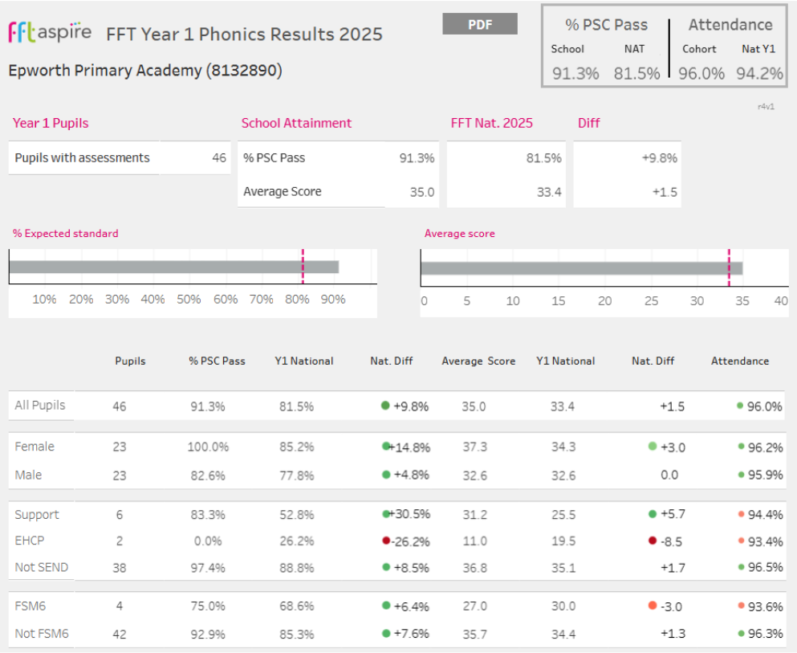
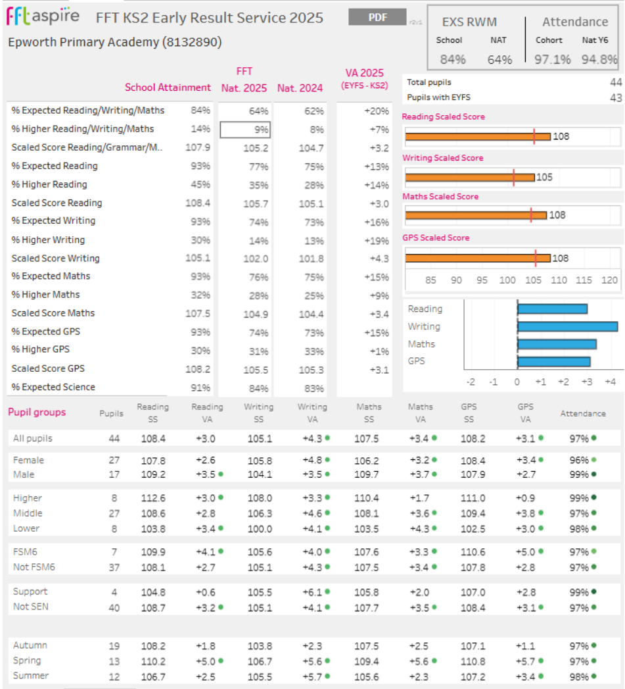

Externally provided programmes
Please include the names of any non-DfE programmes that you used your pupil premium (or recovery premium) to fund in the previous academic year.
Programme | Provider
5 minute box
RWI 1:1 intervention | Read Write Inc.
Thrive | Thrive

Service pupil premium funding (optional)
For schools that receive this funding, you may wish to provide the following information: How our service pupil premium allocation was spent last academic year
Our Service premium is spent on:
- PAL (Progress and Achievement Lead) support for children to access as required.
- Subsidising trips and visits where appropriate
- Ensuring where trips are limited to numbers a place is allocated for Service Children.
The impact of that spending on service pupil premium eligible pupils
There were no service children in 24-25.

